

CST4390: Postgraduate Individual Project

The Impact of a Sedentary Lifestyle on Health: A Data-Driven Approach to Identifying Patterns and Solutions

Coursework 1: Project Proposal
Submission: Monday 7th July 2025

Student ID:M00810926

Name: Abdullahi Mohamed

CAMPUS: HENDON

Introduction
The aim of the project is to analyse data on sedentary behaviour across demographic groups, and its impact on health outcomes, with a focus on stress levels, sleep quality and overall wellbeing. The project will collect data through surveys, data analysis, visualising data and develop recommendation to address negative health implications of prolonged sitting and limited physical activity.
Problem within subject matter
There has been an increase in sedentary behaviour across demographic groups, posing major health risk. Workplaces and modern lifestyle changes have led to excessive time spent sitting, resulting in both physical and mental health challenges. The COVID-19 pandemic has worsened this trend, with a rise in remote occupation. The problem can be investigated through data collection and analysis to identify patterns and find solutions.
Reason to investigate the chosen problem
Health: Sedentary behaviour is linked to numerous chronic health problems including cardiovascular disease, diabetes and obesity.
Mental Health: Understand how inactivity physically can affect mental wellbeing.
Demographic: A variety of age groups and occupational categories show patterns of sedentary behaviours.
Pandemic-Related Changes: COVID-19 has totally altered work and study habits, making this research particularly timely and relevant.
Actionable Insights: Data-driven recommendations can lead to practical interventions that improve health outcomes across populations.
Aim: To gather insights on sedentary behavioural patterns across demographics group by using methodologies such collection of data analysis and visualization.
An analysis of data will find correlations between sitting time, physical fitness and various health metrics including stress, sleep quality and overall wellbeing. The completion of the project will enhance knowledge of how occupational and lifestyle factors and influences health outcomes and provide evidence-based recommendations for reducing sedentary behaviours.

Objectives
The project is split into many sections:
- Find associations between sitting time and reported stress levels across demographic groups.
- Evaluate the relationship between physical activity levels and mental health.
- Research how occupational factors can influence sedentary behaviour patterns.
- Assess the impact of sedentary lifestyles on quality of sleep and wellbeing.
- Develop and visualise key findings using Excel, SQL and Tableau.
- Provide data-driven recommendations for reducing sedentary and health outcomes.
Milestones
Milestone 1: Design survey and prepare data collection
Milestone 2: Literature review and survey collection
Milestone 3: Data Analysis in Excel
Milestone 4: Data exploration in SQL
Milestone 5: Data visualising in Tableau
Milestone 6: Analyse findings, produce recommendations and submit Final Report
Motivation
The aspiration stems from noticing how sedentary lifestyles represents a significant public health concern, using data collection and analysis to identify patterns in sedentary behaviour and their potential implications provides valuable insights for individuals. The project is motivated by potential to develop evidence-based strategies that can meaningfully improve physical and mental health outcomes across populations.

Risk Analysis
- Minimal survey response can lead to insufficient data for meaningful analysis
- Bias within survey response can affect data accuracy, address through clear questioning process and cross-validation with metrics.
- Maintain communication with supervisors and project timelines due to complexity of health data.
- Technical challenges in processing data visualization, allocate time for developing necessary skills in set tools.
- Incompletion of literature review can lead to important context not being included, therefore conducting systematic review of existing research is important to do so.
Contingency time
Multiple timed breaks have been implemented in this project to tackle unexpected challenges, allowing for additional data collection if initial response is insufficient and provide flexibility for refining analysis approaches based on findings.
Literature Review Section
Background research guides analytical project, obtaining a literature evaluation allows for a guided use of data analysis within the project.
Title: Sedentary Lifestyle: Overview of updated evidence of potential health risks
Description: Sedentary behaviours affect one-third of population, with significant health risks such as cardiovascular diseases and cancer. Reducing sedentary time and increasing physical activity are crucial for improving public health outcomes (Park,2020).
Title: Time spent being sedentary: an emerging risk factor for poor health
Description: Sedentary time is a great factor in causing cardiovascular disease and cancer. It has a global impact on mortality, comparable to tobacco use and obesity. Replacing sitting time with light physical activity improves health outcomes. Understanding the process behind sedentary times and physical activity is important for developing public health interventions (Salman, 2019).
Title: Sedentary Behaviour, Exercise, and Cardiovascular Health
Description: Sedentary behaviour and physical inactivity are major risk factors for cardiovascular diseases and mortality. This review highlights the usefulness of exercising to prevent chronic diseases and addressing heart failure. It emphasises the need for global attempt to reduce sedentary behaviour and promote physical activity (Lavie, 2019).

Gantt Chart
Below is the step-by-step task necessary to complete this project within the timeline.
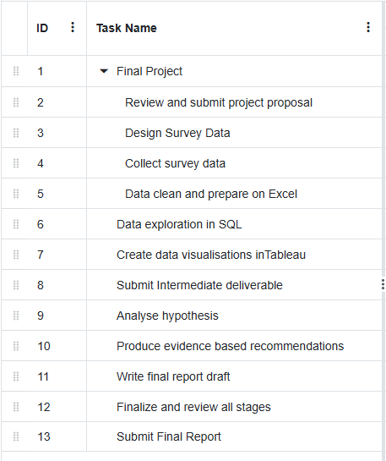
Figure 1 - Gantt Chart Table

Visualisations of Gantt Chart
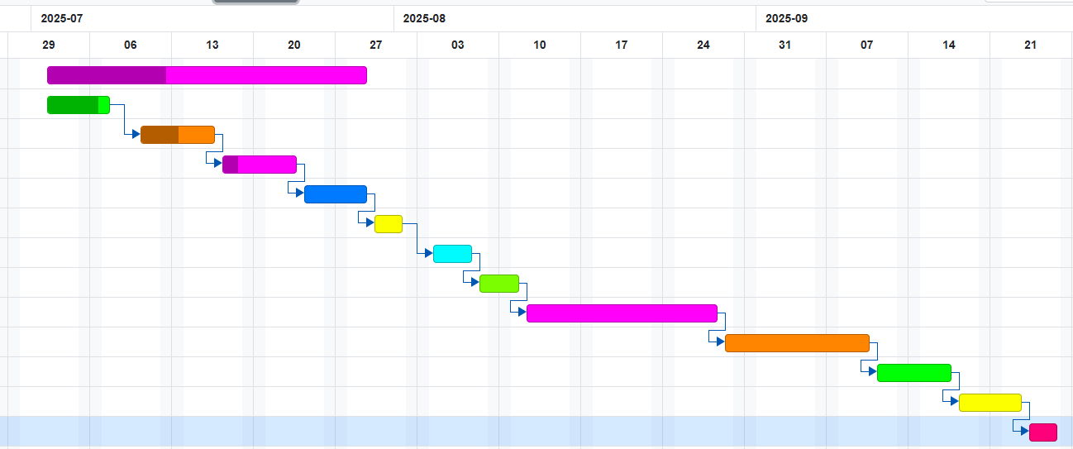
Figure 2 - Gantt Chart Visualisation
Evaluation
The project will be assessed and evaluated through several ways:
- Correlations between sedentary behaviour and health outcomes.
- Demographic representation in the collected data.
- Quality data visualisations.
- Application of recommendations development.
- Feedback from academic supervisors on methodology and findings.
- Self-reflection on research process.
Resource
There will be plenty of resources needed for this project, including three surveys collecting data on stress levels, demographics information, physical activity patterns, and sleep quality. Excel will be used to prepare data, SQL to find patterns, and Tableau to produce interactive dashboard. Academic journals and public health databases will provide context and comparative analysis with recommendations.

References
Park, J.H., Moon, J.H., Kim, H.J., Kong, M.H., Oh, Y.H., 2020. Sedentary lifestyle: Overview of updated evidence of potential health risks. PMC. Available at: https://pmc.ncbi.nlm.nih.gov/articles/PMC7700832/ [Accessed 20 March 2025].
Salman, D., Farooqi, M., McGregor, A., & Majeed, A. (2019). Time spent being sedentary: an emerging risk factor for poor health. British Journal of General Practice, 69(683), 278-279. https://doi.org/10.3399/bjgp19X703781. [Accessed 21 March 2025].
Lavie, C.J., Ozemek, C., Carbone, S., Katzmarzyk, P.T. and Blair, S.N., 2019. Sedentary behavior, exercise, and cardiovascular health. Circulation Research, 124(5). Available at: https://doi.org/10.1161/CIRCRESAHA.118.312669. [Accessed 22 March 2025]

